Bacterial cellulose-based paper production coated with poly-ethylene oxide/poly-vinyl alcohol

Highlights

BC was used as the main component in paper production.

The coating process of bacterial cellulose-based paper with poly-ethylene oxide/poly-vinyl alcohol (PEO/PVC) was successfully carried out with rod coating method.

The result showed the coating treatment improved the mechanical, thermal, water barrier, and quality of the paper.

Abstract
Wood and non-wood cellulose are commonly used as raw materials for paper production. This study aims to produce paper from bacterial cellulose (BC). Due to its high-water binding property, BC was rod-coated with the mixture of polyethylene oxide (PEO)/polyvinyl alcohol (PVA). The used of PEO was varied from 0.5, 1.0, 1.5, 2.0, and 2.5 g (w/v) whereas the use of PVA was 0.5 g (w/v). The BC paper was characterized using SEM, FTIR, and tensometer whereas the paper quality was tested by the Indonesia National Standard (SNI). The result showed the coating treatment improved the mechanical, thermal, water barrier, and quality of the paper. The optimum composition was found in the BCpAO2 sample, where the composition of PEO in the coating solution is 1.0 g. This is due to the further addition of PEO to the coating solution, makes the coating film bind more water.

1. Introduction
The demand for pulp and paper is currently rising rapidly around the world as the population increases. Approximately more than 400 million metric tons of paper and paperboard are produced globally annually (Bajpai, 2016), (Otieno et al., 2021). Typically, wood and non-wood cellulose fibers are utilized in the production of pulp, which is the primary ingredient of paper (Achparaki et al., 2012). Other than plant-based cellulose, bacterial cellulose (BC) has the potential to be used as a cellulose resource. When compared to plant-based fibers, BC is more advantageous for cellulose isolation because it is free of lignin and hemicellulose, avoiding the need for a pulping and bleaching process, thus making it more environmentally friendly and energy efficient. In terms of fiber growing time, BC is secreted considerably shorter than tree growing time, ordinarily 7–14 days after the bacteria are introduced into the media (K.M. Pasaribu et al., 2020; K.M. Pasaribu et al., 2020; Srikandace et al., 2022; Hasibuan et al., 2021). Additionally, BC is free from pulping process, therefore BC is a promising alternative for cellulose resource (Abd El-Sayed et al., 2020; Saijonkari-Pahkala, 2001; Gea et al., 2018; Gea et al., 2022).
Bacterial cellulose is an attractive natural material with its remarkable physical-chemical properties, ecologically friendly processing, affordable price, hydrophilicity, great biocompatibility, and biodegradation capability (Zuhra et al., 2020; Indriyati et al., 2021; Pasaribu et al., 2023). Because of its excellent properties, BC was used as an ultra-strength additive to produce paper with fine fiber networks (Vandamme et al., 1998), (Gea et al., 2023), in the recovery of damaged paper (Pasaribu et al., 2023), and in the development of magnetic paper for anti-counterfeiting applications (Sriplai et al., 2018). Modified BC has also been applied in the production of special fire retardant paper (Skočaj, 2019). However, until now, BC has been investigated more as an additive than as a primary ingredient in the production of paper (Kalyoncu and Peşman, 2020; Campano et al., 2018; Janbade et al., 2022). This is due to its high water-binding properties (Ul-Islam et al., 2012), (Rebelo et al., 2018). In this study, BC is used as the main component in paper production without the addition of cellulose wood-based pulp. Hence, the rod-coated technique is required to resolve the drawbacks, and the mixture of poly-vinyl alcohol (PVA) and poly-ethylene oxide (PEO) was essential for this purpose. Due to the efforts in barrier performance improvement of porous paper, can be done by blocking the diffusion path of liquid/gas molecules on the pore surface of the paper. The common protocol used is to coat the paper substrate with a polymer film coating (Shen et al., 2021).
Synthetic polymers such as poly(vinyl alcohol) (PVA) are widely used in material studies because of their good water soluble properties, barrier performance, and mechanical properties, thus they are able to perform excellent film formation (Zhao et al., 2018). Previous study stated, that the use of PVA as a coating film on the paper surface successfully increases the barrier performance of the paper, because the PVA film can properly block and inhibit the diffusion of permeate molecules in the paper surface pores and increase the mechanical strength of paper (Zhao et al., 2018), (Ren et al., 2015). Additionally, it was found in the previous study that the application of PVA/alkyl ketene dimer coating improved the hydrophobicity of coated papers (Shen et al., 2021).
Meanwhile, poly(ethylene oxide) (PEO) shows similar properties to PVA, such as biocompatible, and water soluble (Hashim and Habeeb, 2018). Since PEO is highly soluble in water, it is necessary to crosslink it in order to obtain insoluble nanofibers and fibrous matrices that have applicability as coating materials on paper surfaces (Şimşek et al., 2016). A previous study demonstrates that treating paper with the polymer polystyrene/PEO/poly(methyl methacrylate) delayed water absorption significantly (Ibrahim et al., 2006). Thus, PEO is a suitable polymer to be mixed with PVA polymer matrix to form an excellent mechanical coating film with the ability to delay water absorption (Muralidharan et al., 2016). In addition, the mixture of PVA and PEO has the potential to enhance the grammatical, and brightness of the paper (Ul-Islam et al., 2012; Rebelo et al., 2018; Shen et al., 2021). Therefore, the characterization results of this study are expected to be a reference for further studies related to the application of the paper produced. This work also included the use of starch, alum, and kaolin, which are commonly used as fillers and adhesives in commercial papermaking (Dong et al., 2008), (Hubbe and Gill, 2016).

2. Materials
Glucose (C₆H₁₂O₆), urea (CH₄N₂O), glacial acetic acid (CH₃COOH_{(l)}), sodium hydroxide (NaOH), sodium hypochlorite (NaOCl), PVA, PEO, potassium alum (KAl(SO₄)₂·12H₂O), and kaolin were purchased from Sigma-Aldrich and used without further purification. Cationic starch was donated by PT. Indah Kiat Pulp & Paper, Riau, Indonesia. Acetobacter xylinum was provided by Polymer and Material Laboratory, Chemistry Postgraduate, Universitas Sumatera Utara, Indonesia. Coconut water was purchased from the traditional market in Medan, Indonesia.

2.1. BC production
An amount of 20 g glucose and 10 g urea were added into 2 L of coconut water and homogenized by magnetic stirrer. Glacial acetic acid of 2 mL was added to reach pH 4. As much as 10 mL Acetobacter xylinum was added, and the solution was inoculated at room temperature for 7 days.

2.2. BC purification
The BC sheets were taken from the media and rinsed under the tap water, immersed in NaOH 2.5% for 24 h to remove the remaining bacteria and bleached using NaOCl 2.5% for 24 h then washed by using distilled water until pH neutral, then disintegrated using a mechanical stirrer with the rate blade rotation of 300 rpm to produce BC slurry. The sample was stored at 4 °C.

2.3. Production of BC-based paper
An amount of 20 g of dry BC was mixed with 0.4 g potassium alum, 1 g cationic starch, and 1 g kaolin in 50 ml distilled water under constant stirring to produce pulp. The pulp was dried using heat pressure at 70 °C for 2 h.

2.4. Rod coating of BC-based paper
As much as 0.5 g of PVA was dissolved in 100 mL distilled water with constant stirring at 90 °C for 4 h and followed by ultrasonication treatment for 2 h. PEO was added accordingly (Table 1) into PVA solution with constant stirring at 70 °C for 2 h.

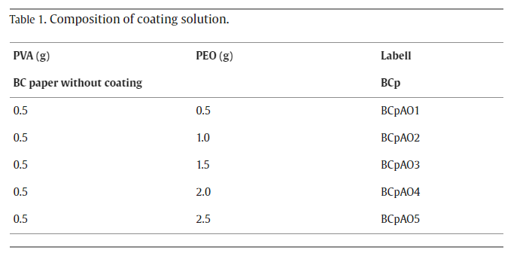
The coating process of BC paper was carried out with the rod coating method in which the BC paper was placed on a hard-flat surface. The coating solution was then dropped carefully on the edge paper surface while the rod was placed, the rod moved in a constant direction to evenly distribute the coating solution. The coated paper was then air-dried. The schematic procedure is shown in Fig. 1.

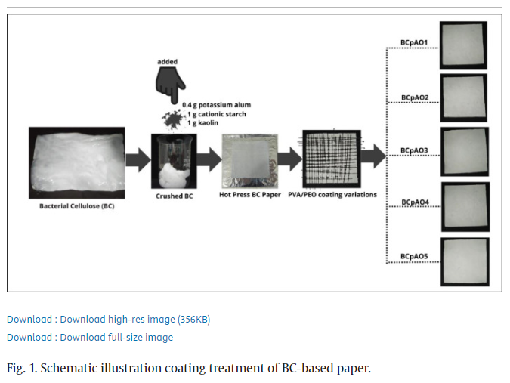

2.5. Characterizations
Functional groups were determined using Platinum-ATR, Bruker, Alpha in wavelengths with a range of 4000–400 cm⁻¹. Mechanical properties of the BC-based papers were tested using Tensometer GOTECH AL-7000 M at 20 °C, 65% RH moisture, and 60 × 15 mm² dimension at 5 mm/min with 1 KN load. Crystallinity index was observed by using XRD by scanning 2θ angle at 7–70° range using Shimadzu XRD-6100 diffractometer. Morphological analysis was done using SEM EVO MA Zeiss Bruker operated at 20 kV. The wettability test was carried out using a contact angle goniometer, by dripping water and letting the drop stabilize on the sample surface for 4 s. The droplet on the surface of the sample was then captured using a high-speed (120 fps) camera. In the final stages, Image J software was used to calculate the tangent of the droplet to the sample surface in order to determine contact angles. Three measurements were made on each sample. Thermal degradation test was carried out on the TGA EXTAR 7300 series at the temperature range of 30–600 °C, the temperature rise of 10 °C/min under nitrogen gas condition. The quality of BC-based paper such as, Grammage, brightness level, water contents, and opacity were performed according to SNI ISO 536:2, 2470–1:2016, 287:2014, and 2471:2014 standards respectively.

3. Results and discussion

3.1. Mechanical properties of BC-based paper
The BC pellicle disintegration process in order to create BC slurry in paper production lowers the tensile strength of BC compared to the tensile strength of pure BC sheets. The mechanical characteristics of BC-based papers are shown in Fig. 2. The graph shows that BCp has lower mechanical properties compared to all paper samples that have been coated. This result in accordance with the previous analysis that the coating treatment resulted better mechanical properties which is due to the hydrogen bonding between the paper and the PVA/PEO mixture (Al-Hazeem and Ahmed, 2020), (Waly et al., 2021). Moreover, in Table 2, it can be seen that BCpAO1 samples (were not coated) had a tensile strength of 7.42 ± 0.12 MPa, which was lower than the BCpAO1 samples (were coated), which had a tensile strength of 7.93 ± 0.16 MPa. Generally, the table also shows that the all coated paper had higher tensile strength compared to the samples that did not receive the coating treatment. Additionally, it was observed that samples that were coated had a higher Young's modulus value compared to samples that were not coated. Among all the evaluated samples, BCpAO2 sample (PVA: PEO (0.5: 1.0)) was determined to have the highest Young's modulus value of 2.4 GPa. However, further addition of PEO composition to the coating makes the Young's modulus of the tested samples decrease. This can be seen in samples BCpAO4 and BCpAO5 which have lower Young's modulus compared to sample BCpAO2. This is in accordance with previous research in which PEO has a low young modulus, in the form of thin films it is around 0.2–5.0 GPa and in highly crystalline bulk material is around 0.29 GPa (Bellan et al., 2005). While the sample with the highest elongation value was found in BCpAO3 (PVA: PEO (0.5: 1.5)) samples with an elongation value of 0.9 ± 0.06%. Therefore, the concentration ratio of PVA and PEO in the PVA/PEO coating material can be adjusted in the paper production process, depending on the planned application of the produced paper.

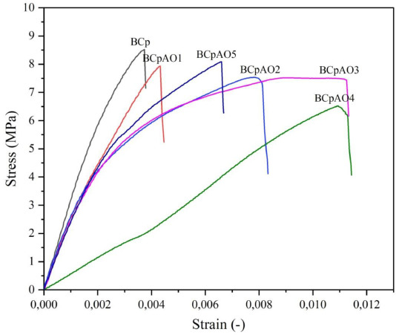

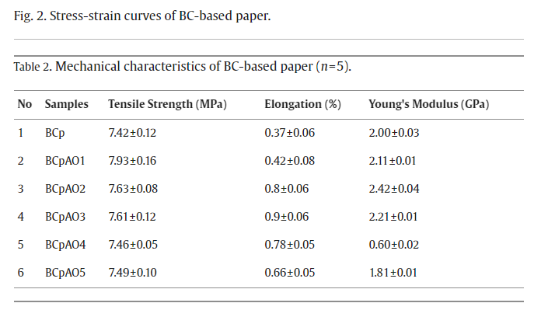

3.2. Morphological of BC-based papers
The morphological analysis of BC-based paper is shown in Fig. 3. It shows that the fillers in the form of cationic starch, potassium alum, and kaolin are trapped in the BC fiber (Fig. 3a). Additionally, this image demonstrates the porosity in the base paper surface shape morphology, which allows liquid molecules to pass through. Therefore, in this case, the coating treatment can be done to create a penetration barrier by obstructing the pores on the surface of the base paper. In the BCpAO1 sample (Fig. 3b), it can be seen that the PVA/PEO coating layer is very thin, thus the paper contours can still be observed. It was noted in sample BCpAO2 (Fig. 3c) that the increase in PEO composition in the PVA/PEO coating resulted in the formation of a film layer that nearly entirely encased the paper fiber. However, a further increase in PEO composition in BCpAO3 (Fig. 3d), BCpAO4 (Fig. 3e), and BCpAO5 (Fig. 3f) samples, respectively, was observed to form agglomerated film coating layers. This could occur as a result of the continued addition of PEO to PVA/PEO coating solutions, which made the inter- and intra-chain hydrogen bonds between polymer chains in PVA/PEO weaker compared to PEO hydrogen bonds to water molecules, changing the rheological behavior of PVA/PEO coating solutions (Li et al., 2010). This is in accordance with the previous discussion that the BCpAO2 sample exhibits the highest mechanical properties among all the samples tested.

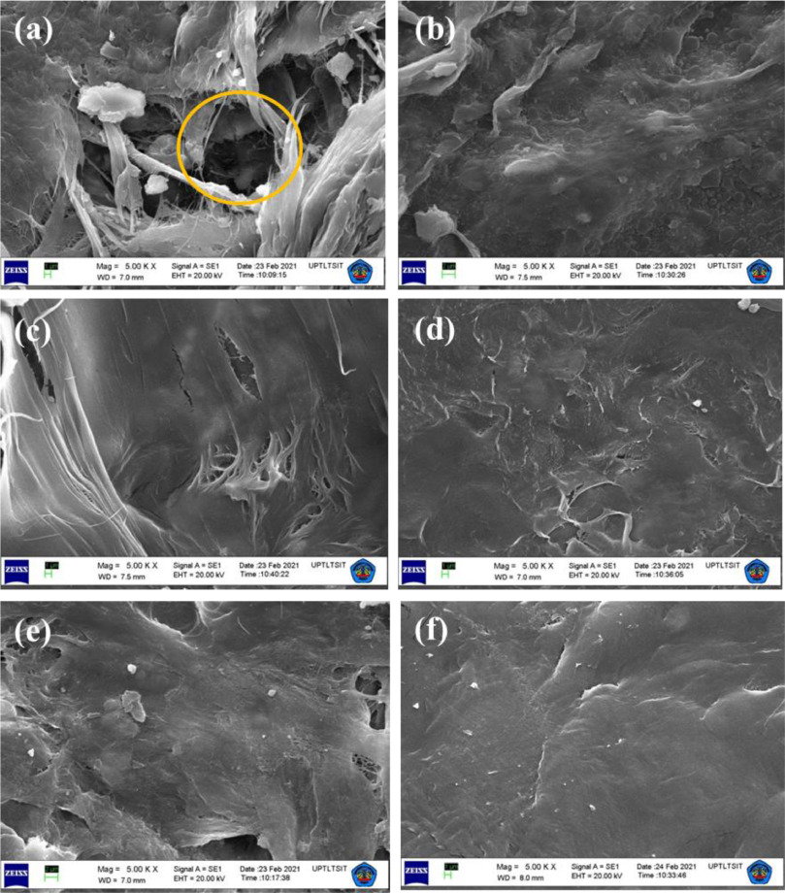
Fig. 3. SEM image of (a) BCp, (b) BCpAO1, (c) BCpAO2, (d) BCpAO3, (e) BCpAO4 and (f) BCpAO5, magnification 5000x.

3.3. FTIR analysis
As shown in Fig. 4, The FTIR spectra of BC confirms the absorption peak at 3339.7 cm⁻¹, indicating the presence of hydroxyl groups (OH) from β-glucose unit. The CH stretching band is indicated by the peak at 2892.4 cm⁻¹, whereas 1640 cm⁻¹ wavenumber indicates CO cyclic rings from the glucose monomer. Moreover, wavenumbers 1431.3 cm⁻¹ and 1312 cm⁻¹ indicate CH bending group, as well as CO-C at 1103.3 cm⁻¹, represents of β−1,4-glycosidic groups (Auta et al., 2017). Whereas the hydroxyl groups (OH) from β-glucose unit are confirmed at 3339.7 cm⁻¹. Insignificant differences in intensities may be contributed by -OH stretching and PEO/PVA concentrations, as reported previously (Yong et al., 2018). The absorption peak is observed in the interval of 2892.4 – 2885 cm⁻¹ due to the stretching vibration of asymmetrical CH from cellulose. Wavenumber shifts from 2892.4 cm⁻¹ to 2885 cm⁻¹ are due to the presence of hydrogen bonding between PEO and PVA (Holik, 2006), and the intensities decrease due to the increase in aliphatic CH from the PEO (Phruksaphithak et al., 2019). Peaks between 1657.5 and 1640 cm⁻¹ are confirmed as the shifting in BCpAO5, which occurs due to the stretching of symmetrical -OH (Maréchal and Chanzy, 2000). Slight intensity differences in the region of 1423.8–1431.3 cm⁻¹ indicates stretching vibration of asymmetrical CH₂, whereas the stretching vibration of asymmetrical CO-C is confirmed at 1103.3 cm⁻¹. An increase in PEO affects the intensities of CH₂ as the intermolecular interaction between hydrogen bonds within the hydroxyl groups of BC with PEO/PVA. Based on the irregular intensity shifts, the intermolecular interaction of hydrogen bonds among PEO and PVA molecules may be insignificant (Abd El-Kader et al., 2013). In the incorporating process of PEO into PVA, a fraction of the oxygen atoms in PEO can interact with water to further reduce the amount of free water, while other parts can interact with the hydroxyl groups of PVA to form stronger hydrogen bonds, which causes the hydroxyl stretching bonds to shift to lower wavenumbers (Li et al., 2010).

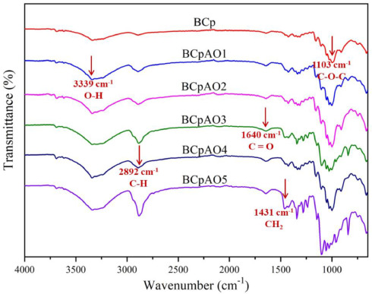
Fig. 4. FTIR Spectra of BC paper with various coating solution.

3.4. Crystallinity index of BC-based papers
Fig. 5 displays the X-ray diffractogram of BC papers and Table 3 shows their crystallinity index. BC diffractogram shows at 14.5°, 16.7°, and 22.6° (Vazquez et al., 2013). The addition of cationic starch, potassium alum, and kaolin emergences of new sharp peaks with high intensity at 12.5° and 25.0° and sharp peaks with low intensity at 26.8°, and 37.8° Increasing the amount of PEO in the coating treatment for BCpAO4 and BCpAO5 samples causes a significant peak change at 22.8°, resulting decrease in the degree of crystallinity. This is due to PEO can create new hydrogen bonds with PVA, weakening the self-hydrogen bonds to a greater extent. As a result, the ability of PVA to crystallize is inhibited, and the size and crystallinity of its crystal lines are reduced (Li et al., 2010).

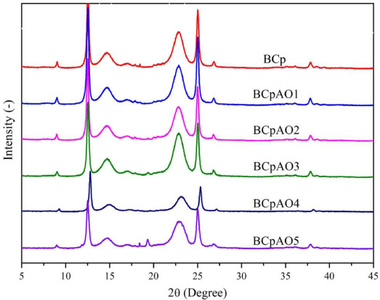
Fig. 5. Diffractogram pattern of BC-based papers.

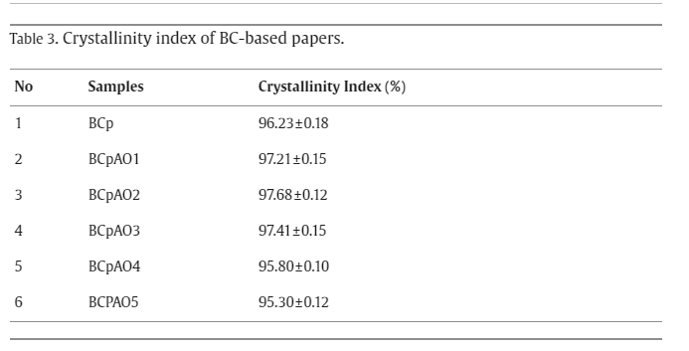

3.5. Water contact angle
In applicative material science, the contact angle has become one of the thermodynamic properties that is widely discussed since it can describe the wettability of the solid surface of the sample produced (Marmur et al., 2017). The test results in Fig. 6, shows that all the samples tested have a contact angle below 90°, thus they are classified as materials with hydrophilic properties. This is because the base material in paper is a network of cellulose fibers, which are hydrophilic, have a high affinity to water and rapidly absorb water (Liukkonen, 1997). Nevertheless, in this study, it was demonstrated that the PVA/PEO coating treatment on the paper was successful in increasing the contact angle of the sample from 54.22 ± 1.21° in the BCp (paper with no coating treatment) into 88.98 ± 1.24° in the BCpAO2 (paper with coating treatment). This study also demonstrated that PVA/PEO coatings can increase the contact angle of the papers because prior research indicated that the use of PEO homopolymer as a paper coating agent makes the paper surface even more hydrophilic than untreated paper (Ibrahim et al., 2006). Moreover, the use of homopolymer PVA as a coating agent also reported to change the surface property of the base material from hydrophobic to hydrophilic (Zhao et al., 2018). This is considered to be caused due to hydrogen bonding that forms between PVA and PEO polymers, reducing their affinity to water molecules. Thus, the use of PVA/PEO as coating material, successfully reduces the paper wettability. This demonstrates that the manufacture of BC-based paper with PVA/PEO coating has a higher water barrier compared to wood paper due to the lower contact angles of kraft lignin and mechanical pulp, which are 67° and 73°, respectively, as reported in a previous study (Liukkonen, 1997). This is also in line with the morphological findings, which show that increasing the PEO content in the coating solutions on the BCpAO3, BCpAO3, and BCpAO5 samples causes the water barrier to decrease because PEO possess a higher ability to form hydrogen bonds with water molecules (Li et al., 2010).

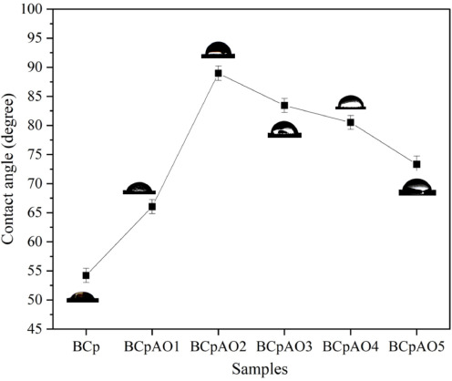
Fig. 6. Water contact angle graph of BC-based papers.

3.6. Thermal properties analysis
Thermal stability characteristics of BC paper was carried out to analyze the relationship between fibers mass loss and the temperatures (Kabir and Wang, 2013). Mass changes due to several phenomena, such as dehydration, decompositions, and oxidation of materials against temperature and time (Awal et al., 2010). Fig. 7a, displays the thermal gravimetric of BC-based papers. There are three stages of mass loss of BC fibers with the increase of temperature. The first stage of mass reduction occurs at 150–210 °C where the water content in BC fibers was removed. This also implied that amorphous parts absorbed the water, whereas the crystalline part did not absorb water. Subsequently, at this temperature, internal structure of BC appeared to be denser due to the loss of water content (Gao et al., 2011). The second step of mass reduction occurred in the interval of 210–330 °C (Fig. 7b). At this temperature, the glycosidic bonds in the fibers cleavage, particularly CO and CC bonds (Gao et al., 2011). The final mass reduction occurs at 600 °C, where there is constant mass loss of the samples. This result conform with previous study that thermal degradation at higher than 400 °C allowed the fibers structure to be reformed into graphitic structure which tend to be more subtle (Gao et al., 2011). From graphich, it reveals that the coated BC-based papers possess higher termal stability compare to base BC-based papers. This was due to the excellent thermal stability of the PVA (Saini et al., 2017), as well as PEO which has higher thermal stability than BC (Inai et al., 2018). However, it was observed in Table 4, that BCpAO3, BCpAO4, and BCpAO5 experience lower residual mass and highest thermal degradation compared to BCpAO1 and BCpAO2. This is in accordance with the discussion in the contact angle section, which states that the water barrier in BCpAO3, BCpAO4, and BCpAO5 is lower than in BCpAO1 and BCpAO2.

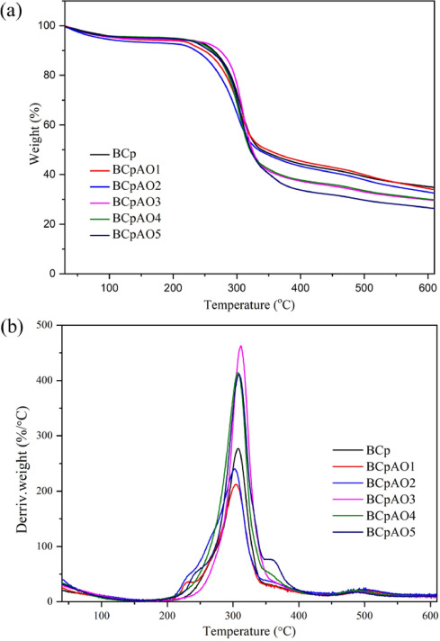
Fig. 7. (a) TGA and (b) DTGA curves of BC-based paper samples.

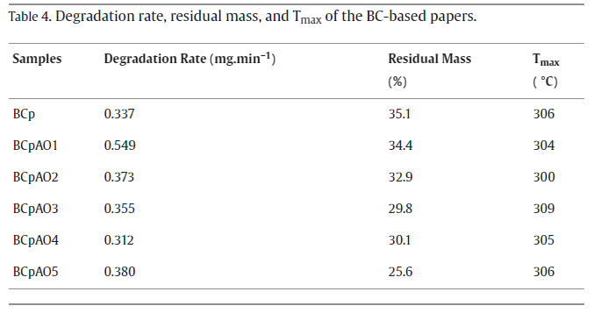

3.7. Quality of BC-based papers
The BC-based paper was assessed using the Indonesian national standard (SNI) for grammage, brightness, water content, and opacity (Table 5). The table shows that the subjection of coating to BC-based paper increases grammage, enhances brightness, decrease water content, while rises opacity. In table 2, the paper grammage values before and after the coating process are compared. It was found that all of the paper that underwent the coating treatment in this study had higher thickness and grammage values due to structural changes brought on by the application of the coating. In this study, the brightness and opacity of base and coated papers were determined. In this study, the brightness value of the base paper that received the coating treatment increased by about 2% compared to the base paper. In this study, the water content result was observed in line with the water contact angle result, which has been discussed in the previous section, where it was observed that the water content of BCpAO4 and BCpAO5 is higher than BCpAO1 and BCPAO2. Opacity is one of the main characteristics of paper and is defined as a measure of the covering ability of the paper (Farnood, 2009). The results confirm that all PEO coating compositions have the same trending effect on individual paper groups as discussed in the previous section.

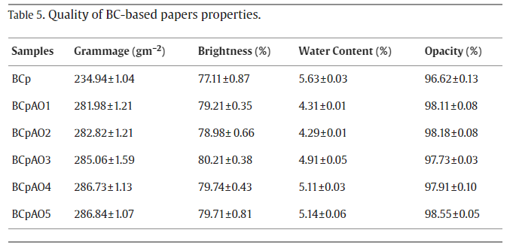

Conclusion
BC-based paper has been successfully fabricated with the addition of alum, cationic starch, kaolin and various concentration of PEO/PVA as coating material. Coating treatment has been shown to impact the properties of the paper being coated. From the results of the study, it is known that coating paper with PEO or PVA results in an increase in the mechanical properties of the paper. The morphological test result showed that the BCpAO2 sample, with a PEO composition of 1.0 g in the coating solution, coated the paper more evenly than other composition variations. Further studies on water contact angle and thermal properties also showed that the most optimal water barrier and thermal degradation properties were found in BCpAO2 samples. This, due to the further addition of PEO to the coating solution, results in a greater PEO hydrogen bond with water than PVA. From the paper quality, it can be seen that the grammage of the paper increases with the coating treatment, but the highest brightness, water content, and opacity properties are also observed most optimally in the BCpAO2 sample.

Declaration of Competing Interest
The authors declare that they have no known competing financial interests or personal relationships that could have appeared to influence the work reported in this paper.

Acknowledgement
The authors would like to thank the Ministry of Culture, Education, Research, and Technology for the funding support in this study via PDUPT scheme, DRPM Program with contract number 95/UN5.2.3.1/PPM/KP-DPRP/2020.

References
- Abd El-Kader et al., 2013
F.H. Abd El-Kader, N.A. Hakeem, I.S. Elashmawi, A.M. Ismail
Enhancement of structural and thermal properties of PEO/PVA blend embedded with TiO2 nanoparticles
Indian J. Phys., 87 (10) (2013), pp. 983-990, 10.1007/s12648-013-0333-1
View article
View in ScopusGoogle Scholar
- Abd El-Sayed et al., 2020
E.S. Abd El-Sayed, M. El-Sakhawy, M.A.M. El-Sakhawy
Non-wood fibers as raw material for pulp and paper industry
Nord. Pulp Pap. Res. J., 35 (2) (2020), pp. 215-230, 10.1515/npprj-2019-0064
View article
View in ScopusGoogle Scholar
- Achparaki et al., 2012
M. Achparaki, et al.
Alternative raw materials for pulp and paper production in the concept of a lignocellulosic biorefinery
Cellulose, Intechopen (2012), pp. 1-26, 10.1039/C7RA00172J%0Ahttps://www.intechopen.com/books/advanced-biometric-technologies/liveness-detection-in-biometrics%0
[Online]. Available:10.1016/j.colsurfa.2011.12.014
View article
Google Scholar
- Al-Hazeem and Ahmed, 2020
N.Z. Al-Hazeem, N.M. Ahmed
Effect of addition of polyaniline on polyethylene oxide and polyvinyl alcohol for the fabrication of nanorods
ACS Omega, 5 (35) (2020), pp. 22389-22394, 10.1021/acsomega.0c02802
View PDF
This article is free to access.
View in ScopusGoogle Scholar
- Auta et al., 2017
R. Auta, G. Adamus, M. Kwiecien
Production and characterization of bacterial cellulose before and after enzymatic hydrolysis
Afr. J. Biotechnol., 16 (10) (2017), pp. 470-482, 10.5897/AJB2016.15486
2017
View article
Google Scholar
- Awal et al., 2010
A. Awal, S.B. Ghosh, M. Sain
Thermal properties and spectral characterization of wood pulp reinforced bio-composite fibers
J. Therm. Anal. Calorim., 99 (2) (2010), pp. 695-701, 10.1007/s10973-009-0100-x
View article
View in ScopusGoogle Scholar
- Bajpai, 2016
P. Bajpai
Global pulp and paper production and consumption
Pulp Pap. Ind. (2016), pp. 9-14, 10.1016/b978-0-12-803411-8.00002-0
View PDFView articleGoogle Scholar
- Bellan et al., 2005
L.M. Bellan, J. Kameoka, H.G. Craighead
Measurement of the Young's moduli of individual polyethylene oxide and glass nanofibres
Nanotechnology, 16 (8) (2005), pp. 1095-1099, 10.1088/0957-4484/16/8/017
View article
View in ScopusGoogle Scholar
- Campano et al., 2018
C. Campano, N. Merayo, C. Negro, A. Blanco
In situ production of bacterial cellulose to economically improve recycled paper properties
Int. J. Biol. Macromol., 118 (2018), pp. 1532-1541, 10.1016/j.ijbiomac.2018.06.201
View PDFView articleView in ScopusGoogle Scholar
- Dong et al., 2008
C. Dong, D. Song, T. Patterson, A. Ragauskas, Y. Deng
Energy saving in papermaking through filler addition
Ind. Eng. Chem. Res., 47 (21) (2008), pp. 8430-8435, 10.1021/ie8011159
View article
View in ScopusGoogle Scholar
- Farnood, 2009
R. Farnood
Review: optical properties of paper: theory and practice
Adv. Pulp Pap. Res. (2009) (2009), pp. 237-352, 10.15376/frc.2009.1.273
View article
Google Scholar
- Gao et al., 2011
W.H. Gao, K.F. Chen, R.D. Yang, F. Yang, W.J. Han
Properties of bacterial cellulose and its influence on the physical properties of paper
Bioresources, 6 (1) (2011), pp. 144-153, 10.15376/biores.6.1.144-153
View article
View in ScopusGoogle Scholar
- Gea et al., 2018
S. Gea, et al.
Enhancing the quality of nata de coco starter by channeling the oxygen into the bioreactor through agitation method
AIP Conf. Proc., 2049 (December) (2018), 10.1063/1.5082469
View article
Google Scholar
- Gea et al., 2023
S. Gea, et al.
The characterization of agitated bacterial cellulose-based paper synthesized at various rotational speeds
AIP Conf. Proc., 040021 (May 2023) (2023), Article 040021, 10.1063/5.0136601
View article
View in ScopusGoogle Scholar
- Gea et al., 2022
S. Gea, K.M. Pasaribu, A.A. Sarumaha, S. Rahayu
Cassava starch /bacterial cellulose-based bioplastics with Zanthoxylum acanthopodium
Biodiversitas, 23 (5) (2022), pp. 2601-2608, 10.13057/biodiv/d230542
View article
View in ScopusGoogle Scholar
- Hashim and Habeeb, 2018
M. Hashim, and A. Habeeb, “Structural and optical properties of (biopolymer blend-metal oxide) bionanocomposites for humidity sensors,” vol. 12, no. 5, pp. 660–663, 2018.
Google Scholar
- Hasibuan et al., 2021
P.A.Z. Hasibuan, et al.
Antimicrobial and antihemolytic properties of a CNF/AgNP-chitosan film: a potential wound dressing material
Heliyon, 7 (10) (2021), p. e08197, 10.1016/j.heliyon.2021.e08197
View PDF
This article is free to access.
View in ScopusGoogle Scholar
- Holik, 2006
H. Holik
Handbook of Paper and Board
Wiley-VCH GmbH7Co. KGaA (2006)
Google Scholar
- Hubbe and Gill, 2016
M.A. Hubbe, R.A. Gill
Fillers for papermaking: a review of their properties, usage practices, and their mechanistic role
Bioresources, 11 (1) (2016), pp. 2886-2963, 10.15376/BIORES.11.1.2886-2963
View article
View in ScopusGoogle Scholar
- Ibrahim et al., 2006
K. Ibrahim, et al.
Preparation and characterization of polystyrene-poly(ethylene oxide) amphiphilic block copolymers via atom transfer radical polymerization: potential application as paper coating materials
J. Appl. Polym. Sci., 102 (5) (2006), pp. 4304-4313, 10.1002/app.24886
View article
View in ScopusGoogle Scholar
- Inai et al., 2018
N.H. Inai, A.E. Lewandowska, O.R. Ghita, S.J. Eichhorn
Interfaces in polyethylene oxide modified cellulose nanocrystal - polyethylene matrix composites
Compos. Sci. Technol., 154 (2018), pp. 128-135, 10.1016/j.compscitech.2017.11.009
View PDFView articleView in ScopusGoogle Scholar
- Indriyati et al., 2021
F.Dara Indriyati, I. Primadona, Y. Srikandace, M. Karina
Development of bacterial cellulose/chitosan films: structural, physicochemical and antimicrobial properties
J. Polym. Res., 28 (3) (2021), pp. 1-8, 10.1007/s10965-020-02328-6
View article
Google Scholar
- Janbade et al., 2022
A. Janbade, S. Zaidi, M. Vats, N. Kumar, J. Dhiman, M.K. Gupta
A mini review on current advancement in application of bacterial cellulose in pulp and paper industry
Proceedings of International Conference on Innovative Technologies for Clean and Sustainable Development (ICITCSD –2021) (2022), pp. 435-445
View article
CrossRefGoogle Scholar
- Kabir and Wang, 2013
M.M. Kabir and H.A.O. Wang, “Mechanical and thermal properties of jute fibre reinforced composites,” pp. 71–77, 2013, 10.12783/issn.
Google Scholar
- Kalyoncu and Peşman, 2020
E.E. Kalyoncu, E. Peşman
Bacterial cellulose as reinforcement in paper made from recycled office waste pulp
Bioresources, 15 (4) (2020), pp. 8496-8514, 10.15376/biores.15.4.8496-8514
View article
View in ScopusGoogle Scholar
- Li et al., 2010
L. Li, N. Chen, Q. Wang
Effect of poly(ethylene oxide) on the structure and properties of poly(vinyl alcohol
J. Polym. Sci. Part B Polym. Phys., 48 (18) (2010), pp. 1946-1954, 10.1002/polb.22070
View article
View in ScopusGoogle Scholar
- Liukkonen, 1997
A. Liukkonen
Contact angle of water on paper components: sessile drops versus environmental scanning electron microscope measurements
Scanning, 19 (6) (1997), pp. 411-415, 10.1002/sca.4950190604
View PDF
This article is free to access.
View in ScopusGoogle Scholar
- Maréchal and Chanzy, 2000
Y. Maréchal, H. Chanzy
The hydrogen bond network in I(β) cellulose as observed by infrared spectrometry
J. Mol. Struct., 523 (1–3) (2000), pp. 183-196, 10.1016/S0022-2860(99)00389-0
View PDFView articleView in ScopusGoogle Scholar
- Marmur et al., 2017
A. Marmur, C.Della Volpe, S. Siboni, A. Amirfazli, J.W. Drelich
Contact angles and wettability: towards common and accurate terminology
Surf. Innov., 5 (1) (2017), pp. 3-8, 10.1680/jsuin.17.00002
View article
View in ScopusGoogle Scholar
- Muralidharan et al., 2016
M.N. Muralidharan, S. Mathew, A. Seema, P. Radhakrishnan, T. Kurian
Optical limiting properties of in situ reduced graphene oxide/polymer nanocomposites
Mater. Chem. Phys., 171 (2016), pp. 367-373, 10.1016/j.matchemphys.2016.01.030
View PDFView articleView in ScopusGoogle Scholar
- Otieno et al., 2021
J.O. Otieno, T.N. Okumu, M. Adalla, F. Ogutu, B. Oure
Agricultural residues as an alternative source of fibre for the production of paper in Kenya- a review
Asian J. Chem. Sci. (July) (2021), pp. 22-37, 10.9734/ajocs/2021/v10i119084
View article
Google Scholar
- Pasaribu et al., 2020a
K.M. Pasaribu, et al.
Fabrication and in-vivo study of micro-colloidal Zanthoxylum acanthopodium-loaded bacterial cellulose as a burn wound dressing
Polymers (Basel), 12 (7) (2020), 10.3390/polym12071436
View article
Google Scholar
- Pasaribu et al., 2023
K.M. Pasaribu, et al.
Bioactive bacterial cellulose wound dressings for burns with collagen in-situ and chitosan ex-situ impregnation
Int. J. Biol. Macromol. (2023), Article 123118, 10.1016/j.ijbiomac.2022.123118
View PDFView articleView in ScopusGoogle Scholar
- Pasaribu et al., 2020b
K.M. Pasaribu, S. Gea, S. Ilyas, T. Tamrin, I. Radecka
Characterization of bacterial cellulose-based wound dressing in different order impregnation of chitosan and collagen
Biomolecules, 10 (11) (2020), pp. 1-15, 10.3390/biom10111511
View article
View in ScopusGoogle Scholar
- Phruksaphithak et al., 2019
N. Phruksaphithak, C. Kaewnun, S. O-Thong
Characterization of bacterial cellulose from oil palm shoot juices and coconut juice/poly(Ethylene glycol) biocomposite
J. Renew. Mater., 7 (5) (2019), pp. 493-504, 10.32604/jrm.2019.00020
View article
View in ScopusGoogle Scholar
- Rebelo et al., 2018
A.R. Rebelo, A.J. Archer, X. Chen, C. Liu, G. Yang, Y. Liu
Dehydration of bacterial cellulose and the water content effects on its viscoelastic and electrochemical properties
Sci. Technol. Adv. Mater., 19 (1) (2018), pp. 203-211, 10.1080/14686996.2018.1430981
View PDF
This article is free to access.
Google Scholar
- Ren et al., 2015
J. Ren, S. Wang, C. Gao, X. Chen, W. Li, F. Peng
TiO2-containing PVA/xylan composite films with enhanced mechanical properties, high hydrophobicity and UV shielding performance
Cellulose, 22 (1) (2015), pp. 593-602, 10.1007/s10570-014-0482-1
View article
View in ScopusGoogle Scholar
- Saijonkari-Pahkala, 2001
K. Saijonkari-Pahkala
Non-wood plants as raw material for pulp and paper
Agric. Food Sci. Finl., 10 (SUPPL) (2001), pp. 10-95, 10.23986/afsci.5707
View article
View in ScopusGoogle Scholar
- Saini et al., 2017
I. Saini, A. Sharma, R. Dhiman, S. Aggarwal, S. Ram, P.K. Sharma
Grafted SiC nanocrystals: for enhanced optical, electrical and mechanical properties of polyvinyl alcohol
J. Alloys Compd., 714 (2017), pp. 172-180, 10.1016/j.jallcom.2017.04.183
View PDFView articleView in ScopusGoogle Scholar
- Shen et al., 2021
Z. Shen, A. Rajabi-Abhari, K. Oh, G. Yang, H.J. Youn, H.L. Lee
Improving the barrier properties of packaging paper by polyvinyl alcohol based polymer coating—Effect of the base paper and nanoclay
Polymers (Basel), 13 (8) (2021), 10.3390/polym13081334
View article
Google Scholar
- Şimşek et al., 2016
M. Şimşek, S. Çakmak, M. Gümüşderelioğlu
Insoluble poly(ethylene oxide) nanofibrous coating materials: effects of crosslinking conditions on the matrix stability
J. Polym. Res., 23 (11) (2016), 10.1007/s10965-016-1127-x
View article
Google Scholar
- Skočaj, 2019
M. Skočaj
Bacterial nanocellulose in papermaking
Cellulose, 26 (11) (2019), pp. 6477-6488, 10.1007/s10570-019-02566-y
View article
View in ScopusGoogle Scholar
- Srikandace et al., 2022
Y. Srikandace, et al.
Bacterial cellulose production by komagataeibacter xylinus using rice-washed water and tofu processing wastewater with the addition of sodium glutamate
Fibers Polym., 23 (5) (2022), pp. 1190-1196, 10.1007/s12221-022-4729-4
View article
View in ScopusGoogle Scholar
- Sriplai et al., 2018
N. Sriplai, P. Sirima, D. Palaporn, W. Mongkolthanaruk, S.J. Eichhorn, S. Pinitsoontorn
White magnetic paper based on a bacterial cellulose nanocomposite
J. Mater. Chem. C, 6 (42) (2018), pp. 11427-11435, 10.1039/c8tc04103b
View article
View in ScopusGoogle Scholar
- Ul-Islam et al., 2012
M. Ul-Islam, T. Khan, J.K. Park
Water holding and release properties of bacterial cellulose obtained by in situ and ex situ modification
Carbohydr. Polym., 88 (2) (2012), pp. 596-603, 10.1016/j.carbpol.2012.01.006
View PDFView articleView in ScopusGoogle Scholar
- Vandamme et al., 1998
E.J. Vandamme, S. De Baets, A. Vanbaelen, K. Joris, P. De Wulf
Improved production of bacterial cellulose and its application potential
Polym. Degrad. Stab., 59 (1–3) (1998), pp. 93-99, 10.1016/s0141-3910(97)00185-7
View PDFView articleView in ScopusGoogle Scholar
- Vazquez et al., 2013
A. Vazquez, M.L. Foresti, P. Cerrutti, M. Galvagno
Bacterial cellulose from simple and low cost production media by gluconacetobacter xylinus
J. Polym. Environ., 21 (2) (2013), pp. 545-554, 10.1007/s10924-012-0541-3
View article
View in ScopusGoogle Scholar
- Waly et al., 2021
A.L. Waly, A.M. Abdelghany, A.E. Tarabiah
Study the structure of selenium modified polyethylene oxide/polyvinyl alcohol (PEO/PVA) polymer blend
J. Mater. Res. Technol., 14 (2021), pp. 2962-2969, 10.1016/j.jmrt.2021.08.078
View PDFView articleView in ScopusGoogle Scholar
- Yong et al., 2018
C. Yong, et al.
Interfacial modification mechanism of nanocellulose as a compatibilizer for immiscible binary poly(vinyl alcohol)/poly(ethylene oxide) blends
J. Appl. Polym. Sci., 135 (9) (2018), pp. 1-11, 10.1002/app.45896
View article
View in ScopusGoogle Scholar
- Zhao et al., 2018
X. Zhao, D. Xiong, Y. Liu
Improving surface wettability and lubrication of polyetheretherketone (PEEK) by combining with polyvinyl alcohol (PVA) hydrogel
J. Mech. Behav. Biomed. Mater., 82 (March) (2018), pp. 27-34, 10.1016/j.jmbbm.2018.03.014
View PDFView articleView in ScopusGoogle Scholar
- Zuhra et al., 2020
C.F. Zuhra, Y. Muis, S. Gea, S.A. Amaturrahim, K.M. Pasaribu, and S.U. Rahayu, “Morphological investigation of bacterial cellulose/cassava starch nanocomposites produced by in-situ process in agitated culture,” no. Icosteerr 2018, pp. 1042–1046, 2020, 10.5220/0010096710421046.
Google Scholar

